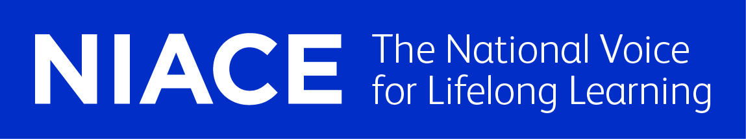
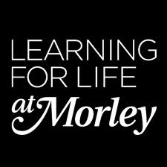
Educate Out Prejudice Curriculum Pilot
Improve your Reading and Writing Entry 2 Literacy
Contents:
- Lesson Plan (pp. 2 – 4)
- Group Profile with Equality and Diversity Statement (pp. 5)
- Resources (pp. 6 – 10)

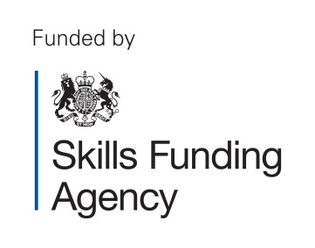
The creation of this material by Morley College has been financed by the Skills Funding Agency Equality and Diversity Innovation Fund 2013/14.Copyright in this material is vested in the Crown but it is made freely available through an Open Government Licence. This licence enables you to use and adapt the material but you must attribute Morley College as the creator and include details of the licence. Full details of the licence are available at http://www.nationalarchives.gov.uk/doc/open-government-licence/
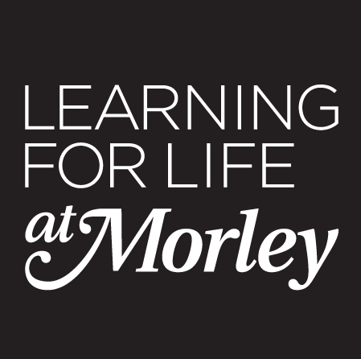 LESSON PLAN Essential Skills 2013-2014

COURSE TITLE: Improve your Reading and Writing Entry 2 Literacy  COURSE CODE: FEBOO3B |  | TUTOR  Catherine O’Shea | WEEK NO  9 | DATE OF LESSON  13/3/14 | NO. OF LEARNERS  16
LEARNING OUTCOMES  (What the student will know or be able to demonstrate by the end of the session) | By the end of the session students will be able to:  1. Answer questions on Anna’s letter about her engagement.  2. Identify the features of a letter, - greeting, introduction, date, address, and signature.  3. Discuss gay marriage and new legislation around gay marriage.

TIME | PURPOSE  (stage of lesson and learning outcome it links to) | LEARNER AND TEACHER ACTIVITY | DIFFERENTIATION/  DIVERSITY* | ASSESSMENT OF LEARNING  (How will students’ progress in the lesson be assessed?) | RESOURCES
15  min | 2 | Group discussion. Teacher asks key questions: Why would you send a letter?  What do you need to have in a letter?  Key letter writing vocabulary. |  | Vocabulary lists. | Vocabulary list.
10  min | 2 | Tell a partner about a time when you received good news in a letter or email. | Differentiated pairs. | Feedback to the whole group. | Images.
10 min | 1/3 | Hand out copies of the letter about an engagement.  Teacher reads letters to the class.  Whole class discussion of the letter. | A letter from a lesbian couple telling their friend about their engagement. | Q and A. | A letter to Mohammed.
15 min | 1 | Reading practice. Read the letter to a partner. Teacher listens to paired reading. | Match pairs with reading level. | Learning support and teacher listen to students reading.
5 min | 1/2/3 | Teacher-led Q and A. Highlight key points of information.
15 min | 1/2 | Students complete reading comprehension questions. | Learning support to assist specific students. | Teacher marks answers. | Worksheets.
20 min | 1/2 | Teacher leads discussion; how would you reply to this letter?  In pairs write a letter in reply.  Read the letters to the class. | Differentiated pairs.  Provide template for some students. | Take in students work to display. | Colourful paper.
20 min | 3 | Leave a Skype recording congratulating your friend on the day of their wedding. Teacher asks students to rehearse. Teacher films pairs on the Flip camera. |  |  | Flip camera/ camera phone.
15 min | 3 | Closing discussion: Teacher asks: Have you ever been treated differently because of something about you? | Discussion about discrimination and homophobic bullying.

*How will your lesson take account of different learning needs, learning styles and abilities/levels? How will it support and promote E and D? For example: Gender, Race, Disability, Cultural and ethnic b/ground, sexual orientation?

EVALUATION OF LESSON (Were the learning outcomes achieved? What was successful? What could be improved? Is there anything that needs to be carried over to the next session?)

This term we had been looking at writing letters. We had already written letters to family and friends and used letters for comprehension exercises. This lesson was carrying on the theme of letter writing while including a letter about a gay wedding. I wanted to present this letter in the same way as any regular text we might use in class. I did not start with a specific focus on LGBT issues and I found it useful to simply embed a text with equalities awareness in this way.

There was very positive engagement in the letter. Interesting and thoughtful replies. I would like to practice more with flip camera technology and use the footage in a future lesson.

In the following lesson we carried on using this source material and response letters. We have also led in to discussions on Equalities.

HOMEWORK

Write a letter from Anna thanking Mohammed for his wedding present.

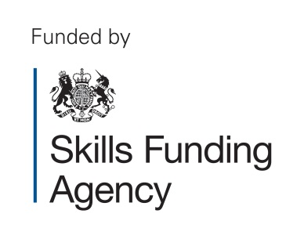
The creation of this material by Morley College has been financed by the Skills Funding Agency Equality and Diversity Innovation Fund 2013/14.Copyright in this material
is vested in the Crown but it is made freely available through an Open Government Licence. This licence enables you to use and adapt the material but you must attribute
Morley College as the creator and include details of the licence. Full details of the licence are available at http://www.nationalarchives.gov.uk/doc/open-government-licence/

Essential Skills 2013-2014

Group Profile with Equality and Diversity Statement

Course Title: Improve your reading and writing Entry 2

Course Code: | FEB003B | Level: | E2
Number on register: | 14 | Tutor: C O'Shea
Comments on the group (issues which impact on the way you organise the group or plan your teaching, e.g. size, range of ability, mixture of beginners/experienced, any learning support needs or disabilities, range of ages, learning styles of students etc.)

In this group there are 14 students with a variety of needs. Five of the students have previously completed Entry 1 and 3 have previously completed Entry 2. All students are able to write their own details and to write a complete sentence although there is a wide range of experience and ability. One student has epilepsy, one has arthritis. 3 students have been identified as needing learning support. All students are in their 30s or 40s there is a mix of genders and most students are either from the Caribbean or from an African country. Three students are from Sierra Leone and three students are Portuguese. Three students are working at a very high level and are close to being ready for Entry 3.

Differentiation for this group based on the above

For this group it is necessary to constantly change groupings and pairings so that the range of abilities all work with different students. It is also necessary to have an extension or stretch activity for every task for the more able and also a simplified version. For the four students working at a lower level it is necessary for me to monitor their progress at every stage to make sure they are following the work. The three students who are almost at entry 3 need entry 3 tasks in some lessons.
Equality and Diversity and Safeguarding

I confirm that I will treat all students equally in this class and make sure that all students treat each other with respect. I will pay full attention to the welfare of my students and report any concerns to my line manager and the college.

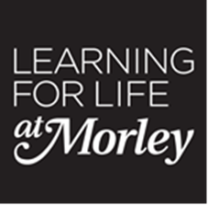
Embedding LGBT - Improve your Reading and Writing Entry Level 2 – Resources

- A letter to Mohammed – Letter (pp.7-8)
- A letter from Anna – Questions (pp.9)
- Vocabulary list (pp.10)

The creation of this material by Morley College has been financed by the Skills Funding Agency Equality and Diversity Innovation Fund 2013/14.Copyright in this material is vested in the Crown but it is made freely available through an Open Government Licence. This licence enables you to use and adapt the material but you must attribute Morley College as the creator and include details of the licence. Full details of the licence are available at http://www.nationalarchives.gov.uk/doc/open-government-licence/

16th February 2014
Anna Stoller
White Hill Road
Edinburgh
EH4 6ST
Scotland
Dear Mohammed,

How are you?
Thank you for the postcard you sent us.
How was your holiday? Did you like Cornwall?
I have some exciting news to tell you.
I am getting married to my girlfriend Liz.
On Valentine’s Day Liz took me out for a meal to a nice restaurant.
Our table had a beautiful view of the city.
When our drinks came I noticed something floating in my champagne.
I just stared at it until I realised that it was an engagement ring.
It was I am very excited.
I used to think that I would never get married.
The new laws in Britain mean we can get married.
We hope that you will be able to come to the wedding.
The wedding will be next year in Scotland.

I will send you more details soon,
Lots of love
Anna,

A Letter from Anna – Questions

Read the letter from Anna.
Answer the questions below:

- Who is the letter to?

- When was the letter sent?

- Where does Anna live?

- What does she ask Mohammed?

- What happened on Valentine’s Day?

- What was in the glass?

- What is her girlfriend’s name?

- Where will the wedding be?

Letter
Date
Name
Address
Postcode
Send
Dear
Lots of love
Valentine’s Day
Married
Engagement
Scotland

